EJERCICIO PROPUESTO – PABLO SUÁREZ PANTALEÓN

Ejercicio 7.

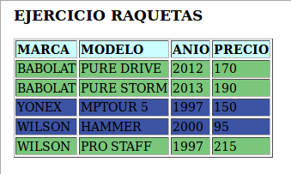
<?xml version="1.0" encoding="UTF-8"?>
<xsl:stylesheet version="1.0" xmlns:xsl="http://www.w3.org/1999/XSL/Transform">
<xsl:template match="/">
<html>
<body>
<h3>EJERCICIO RAQUETAS</h3>
<table border="1">
<tr bgcolor="#CCFFFF">
<th style="text-align:left">MARCA</th>
<th style="text-align:left">MODELO</th>
<th style="text-align:left">ANIO</th>
<th style="text-align:left">PRECIO</th>
</tr>
<xsl:for-each select="/TIENDA/RAQUETA">
<xsl:choose>
<xsl:when test="PRECIO&gt;150" >
<tr bgcolor='#7ac77b'>
<td><xsl:value-of select="MARCA"/></td>
<td><xsl:value-of select="MODELO"/></td>
<td><xsl:value-of select="ANIO"/></td>
<td><xsl:value-of select="PRECIO"/></td>
</tr>
</xsl:when>
<xsl:otherwise>
<tr bgcolor='#3d53a3'>
<td><xsl:value-of select="MARCA"/></td>
<td><xsl:value-of select="MODELO"/></td>
<td><xsl:value-of select="ANIO"/></td>
<td><xsl:value-of select="PRECIO"/></td>
</tr>
</xsl:otherwise>
</xsl:choose>
</xsl:for-each>
</table>
</body>
</html>
</xsl:template>
</xsl:stylesheet>

Ejercicio 8.

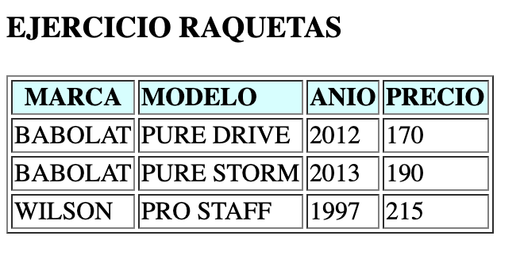
<?xml version="1.0" encoding="UTF-8"?>
<xsl:stylesheet version="1.0" xmlns:xsl="http://www.w3.org/1999/XSL/Transform">
<xsl:template match="/">
<html>
<body>
<h3>EJERCICIO RAQUETAS</h3>
<table border="1">
<tr bgcolor="#CCFFFF">
<th style="text-align:left">MARCA</th>
<th style="text-align:left">MODELO</th>
<th style="text-align:left">ANIO</th>
<th style="text-align:left">PRECIO</th>
</tr>
<xsl:for-each select="/TIENDA/RAQUETA[PRECIO&gt;150]">
<tr>
<td><xsl:value-of select="MARCA"/></td>
<td><xsl:value-of select="MODELO"/></td>
<td><xsl:value-of select="ANIO"/></td>
<td><xsl:value-of select="PRECIO"/></td>
</tr>
</xsl:for-each>
</table>
</body>
</html>
</xsl:template>
</xsl:stylesheet>

Ejercicio 9.

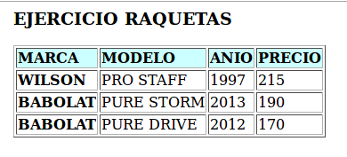
<xsl:for-each select="/TIENDA/RAQUETA[PRECIO&gt;150]">
<xsl:sort select="PRECIO" order="descending"/>
<tr>
<td style="font-weight:bold;"><xsl:value-of select="MARCA"/></td>
Ejercicio 10.
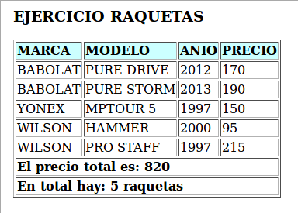
<tr style="font-weight:bold;">
<td colspan="4">El precio total es: <xsl:value-of select="sum(TIENDA/RAQUETA/PRECIO)"/></td>
</tr>
<tr style="font-weight:bold;">
<td colspan="4">En total hay: <xsl:value-of select="count(TIENDA/RAQUETA)"/> raquetas</td>
</tr>

Ejercicio 11.

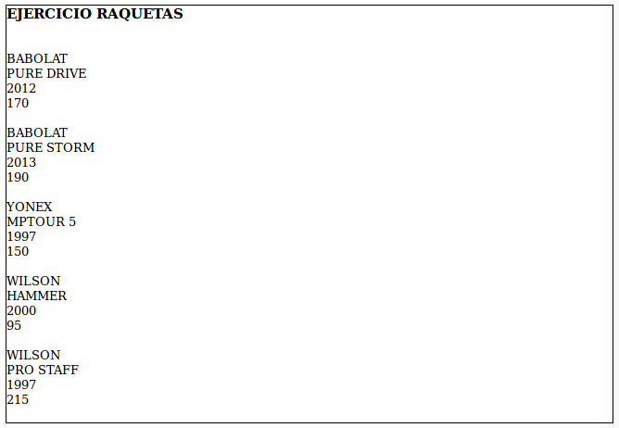
<table border="1" style="border-collapse: collapse" width="100%">
<tr>
<td>
<h3>EJERCICIO RAQUETAS</h3><br/>
<xsl:for-each select="TIENDA/RAQUETA">
<xsl:value-of select="MARCA"/><br/>
<xsl:value-of select="MODELO"/><br/>
<xsl:value-of select="ANIO"/><br/>
<xsl:value-of select="PRECIO"/><br/><br/>
</xsl:for-each>
</td>
</tr>
</table>

Ejercicio 12.

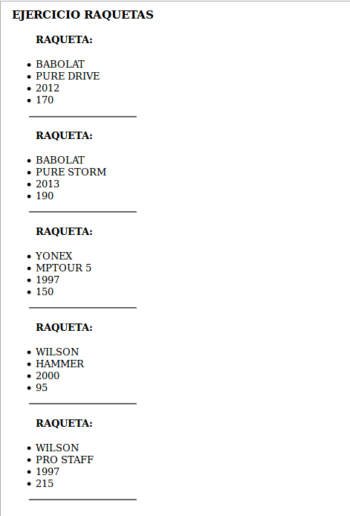
<?xml version="1.0" encoding="UTF-8"?>
<xsl:stylesheet version="1.0" xmlns:xsl="http://www.w3.org/1999/XSL/Transform">
<xsl:template match="/">
<html>
<body>
<h3>EJERCICIO RAQUETAS</h3>
<xsl:for-each select="TIENDA/RAQUETA">
<ul>
<h4>RAQUETA:</h4>
<li><xsl:value-of select="MARCA"/></li>
<li><xsl:value-of select="MODELO"/></li>
<li><xsl:value-of select="ANIO"/></li>
<li><xsl:value-of select="PRECIO"/></li>
</ul>
<hr width="75%"/>
</xsl:for-each>
</body>
</html>
</xsl:template>
</xsl:stylesheet>

Ejercicio 13.

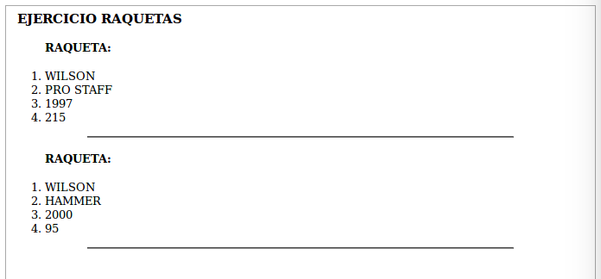
<body>
<h3>EJERCICIO RAQUETAS</h3>
<xsl:for-each select="/TIENDA/RAQUETA[MARCA='WILSON']">
<xsl:sort select="PRECIO" order="ascending"/>
<ol>
<h4>RAQUETA:</h4>
<li><xsl:value-of select="MARCA"/></li>
<li><xsl:value-of select="MODELO"/></li>
<li><xsl:value-of select="ANIO"/></li>
<li><xsl:value-of select="PRECIO"/></li>
</ol>
<hr width="75%"/>
</xsl:for-each>
</body>

